* **Prepare test resources**

e.g. : adb -s 9fe3230e push StabilityResource /sdcard

* **common.ini**

**[Default]***; 2G3GLTE in Irvine, 2G3G in Ningbo*NETWORK_TYPE **=** 2G3GLTE  
LOG_FITER **=** DEBUG  
*;TEST_TYPE = Stability Mini Endurance Endurance_mini*TEST_TYPE **=** Mini  
*#CHINA or US*SITE **=** CHINA  
  
**[Telephony]**ed8b1bf7 **=** 13250979831  
  
**[Message]**ed8b1bf7 **=** 13250979831  
  
**[Wifi]**wifi_name **=** Auto-korea  
wifi_password **=** Performance32  
wifi_security **=** WEP

1. set SITE to US
2. set your local NETWORK_TYPE
3. Telephony and Message:

just add the deviceid and phone number of sdevice

1. Set wifi account

* **Play Store**

1. sign in a google account, close the playstore update for the first time.
2. open Gmail , TAKE ME TO GMAIL🡪Next🡪OK🡪Dismiss
3. open Chrome, Accept & continue🡪No thanks

* **Take a screenshot**

Hold down the volume down button and the power button, and skip pop-up prompts

* **Settings**

1. Set all types of volume to minimum
2. Set Screen lock to None
3. Set Display🡪Sleep🡪Never
4. Open Developer options, enable “Stay awake”

* **Google**

1. sign in a google account
2. open Gmail , TAKE ME TO GMAIL🡪Next🡪OK🡪Dismiss
3. open

* **Contacts**

File Manager🡪Internal storage🡪StabilityResource

Open the vcf file of sdevice

Select Contacts and ALWAYS

Save imported contacts to Device

Enter Contacts app, click the icon shown below

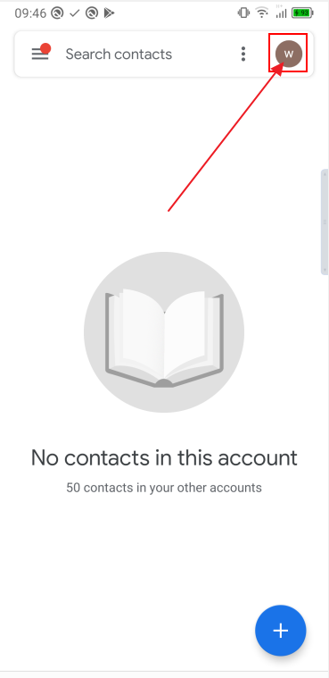

Select Device,

Click “Don’t back up”

* **Messages**

1. More options🡪Settings🡪Notifications🡪close
2. Create a SMS and send it to 1111
3. Create a MMS and send it to 2222

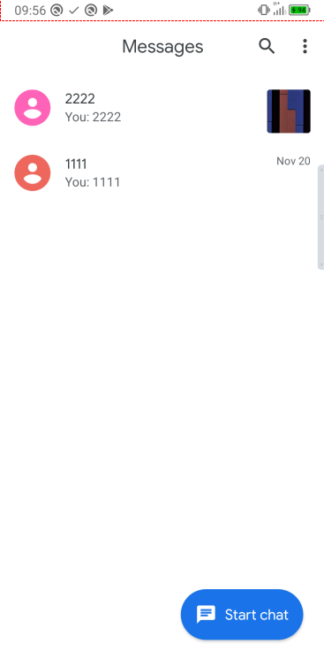

* **Camera**

Open camera, select “ALLOW ALL THE TIME”

* **Calendar**

Add an event , click “Add location”, select ALLOW ONLY WHILE USING THE app,then press back and home

* **Sound Recorder**

ALLOW🡪ALLOW

* **Browser**

1. ALLOW🡪ALLOW ONLY WHILE USING THE APP🡪ALLOW
2. Delete default bookmark ”TCL”
3. Add 5 commonly used websites to bookmarks

E.g.:

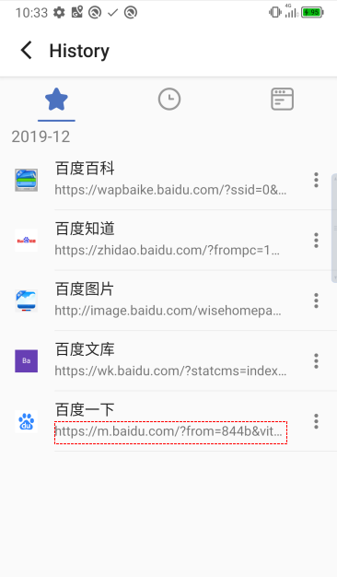

1. Quit Browser, select “Clear history & cache” and “Don’t ask again” , the click CONFIRM

* **YT Music**

1. Select DEVICE FILES ONLY
2. Songs🡪ALLOW🡪ALLOW
3. Back to YT Music homepage,and enter Songs again.